Understanding Age Expectations: Birth to Three

Facilitator’s Guide

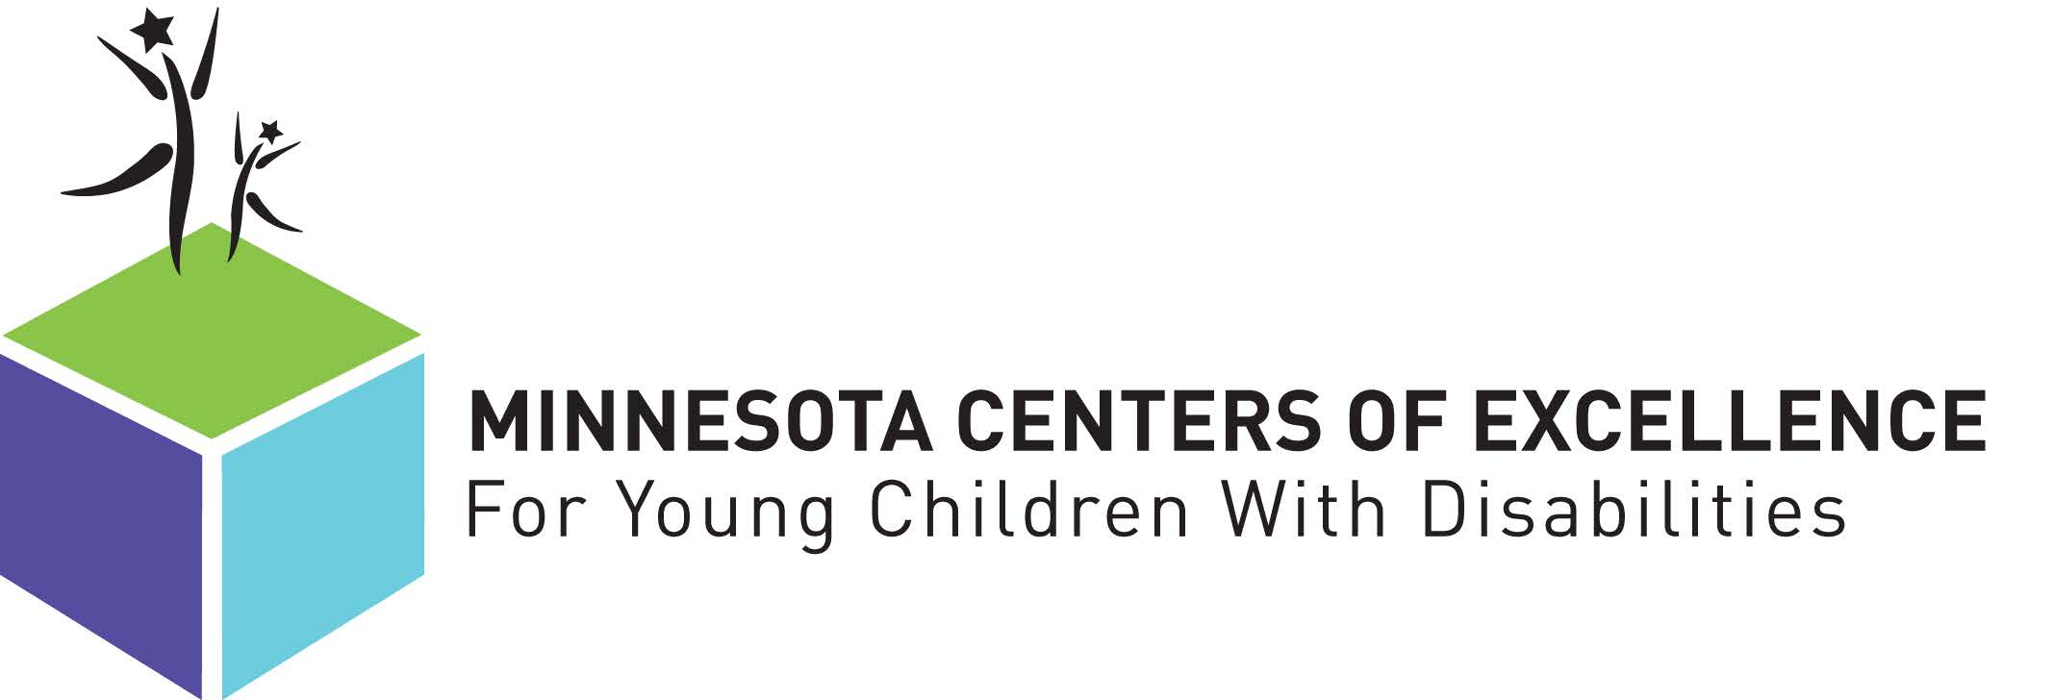

January 2016

PREPARATION for the TRAINING SESSION
Before beginning this training, please review the materials carefully to help you prepare for facilitating this module. Please keep in mind the agenda provided will vary depending upon your rate of delivery, the number of participants in this training, and how well participants know one another. You may also need to adjust learning activity times depending upon these factors.

TRAINING SESSION OBJECTIVE
By the end of this section, participants will have an increased awareness of the need to stay abreast of typical development in order to support young children and their families.

TRAINING SESSION OUTCOMES

By the end of this course, participants should be able to:
- Identify resources for typical development

- Identify typical developmental milestones as they correlate to the child outcomes

- Increase strategies for organizing knowledge of typical child development and functional skills

TRAINING MATERIALS
Review all required materials prior to the session. You will need the following materials for this workshop:

◻ Understanding Age Expectations: Birth to Three Facilitator’s Guide

◻ Power Point presentation

◻ Personal notes and examples

◻ One copy of the participant handouts for each participant

◻ Copies of crosswalked developmental milestone tool test protocol for teams
◻ Flipchart pad

◻ Flipchart markers

◻ Name tags

◻ Means to keep time

◻ Miscellaneous supplies as needed (pens, paper, masking tape)

AUDIO VISUAL RESOURCES

◻ Internet connection
◻ Laptop computer

◻ Projector and screen (surface to hold projector)

◻ Microphone (if needed)

◻ External speakers (if needed)

ROOM SET UP
◻ For workshops of 7 or fewer participants, a U-shaped table set-up is recommended.
◻ For workshops of 8 or more participants, a set-up of group tables accommodating 4 to 5 participants per table is recommended.

AGENDA

Topic | Minutes
- Introductions/Setting the Stage | 10
- View and work through module | 25
- Share back from module | 10
- Review typical development resources and share back | 20
- Build a Functional Table Activity | 45
- Personal Action Planning | 10
TOTAL | 120

TRAINING SESSION

Welcome – 10 minutes | Notes
Session Overview  - View learning module  - Put learning into action via team activity  - Create a personal action plan for continued professional growth | Welcome the group to the training session.  Set the stage for learning; remind participants the focus of this session is to bring typical development to the forefront in order to ensure children receiving services are engaging in activities to support their functional growth and development.  Provide overview of what will take place.
View and Work through Module – 25 minutes | Notes
Present the recorded training module. | Be prepared to stop the recording for learning reviews and discussion pertaining to the questions

FACILITATOR: USE POWERPOINT SCREEN SHOTS AND NOTES FROM THE RECORDED MODULE
Share back from module – 10 minutes | Notes
Following the recorded module, facilitate a discussion with the group regarding “take-aways” from the recording.  Guide the discussion to include identifying ways to incorporate this information with caregivers/families – including the need for functional skill development in preschool. | Using the flip chart paper, make notes of highlights as well as noting areas identified as needing/wanting more information.  - For large groups, identify highlights together; note one-two highlights per piece of paper. Assign each table group a piece of paper and ask them to list needs/wants. Come back together to harvest thoughts and reflections on what is working well, what could be strengthened.  - Identify action steps for the team(s).
Review typical development resources and share back – 20 minutes | Notes
Participants will explore resources suggested through the module with a lens of which would be best resources for families and caregivers.  Highlight the strengths of each tool as well as note components that might be missing.  Have participants share other resources they have used. How do they compare? What is their credibility? | Facilitate discussion; share back to explore how tools can be used to support intervention.  - Generate list of additional resources, noting important components, features  - Following the training, compile list and distribute to participants
Build a Functional Table activity – 45 minutes | Notes
Have participants take a few minutes to review handout #2, Early Childhood Indicators of Progress.  Using the information regarding typical development and the identified child progress monitoring tool (HELP, AEPS, etc.), have participants complete handout #3, the Outcomes Table, by matching which test items align with each outcome and ECIP. Ask participants to then identify specific, functional, observable skills children will demonstrate related to these points. | Depending on the size of the group, this can be done as an independent, pair, or small group activity.  - Once completed, have participants share their work either by presenting to the whole group or by passing completed handout around.
 | - Time Permitting: Once the group has shared, consider asking the group to reflect on what they found challenging or difficult. Did any of the information presented within the module influence the activity? If so, what information and how did it influence the activity?
Personal Action Planning – 10 minutes | Notes
Have participants take a few minutes to complete a personal action plan (handout #4), including the identification of:  - specific steps  - accountability steps  - timeline to progress | Depending on the make-up of the group, have participants partner up and set up an accountability plan, or the facilitator can collection action plans and send out periodic email reminders to support continued focus and growth in this area.

